**Radio Talk Show Report used for introducing ARSH program by the Humanitarian Organization MWOK with partnership of Kapchorwa district youth and Kapchorwa Health trainers to the Community in Eastern Sub-Region on Elgon Radio F.M 95.4 which took place on Friday 19/08/2022 from 8-9PM.**

**1.0 Background**

Humanitarian Organization MWOK in partnership with Kapchorwa district Youth leaders and Kapchorwa district health trainers is trying to lay strategies that can reduce the rate in which STIs and other risk factors that can face youth at adolescence age which is between 10-24 years and to 35 years depending on genetic makeup of the person. **ARSH** program is simply adolescence reproductive sexual health, this program aims at encouraging and advising youth in taking part to control this kind of diseases that can destroy their lives at early stage yet youth are the back born of the nation’s growth. The project implementation is on course in the Three districts of Sebei sub region (Kapchorwa, Kween, Bukwo) of Uganda. This program is aimed at building a strong and healthy society that is struggling to build its self in terms of health, economy, disaster occurrence, environmental management. Thus making the project aims at ensuring that communities are involved in building community resilience for sustainable development through working with district local governments and other actors in disaster prone areas. It is aimed at tackling the imbalances between the Vulnerable and rich, poverty, healthy society, unemployment, environmental management that is caused by different factors in the society. MWOK believes that this can be achieved through effective partnership for community resilience ensuring participation and leverage of local resources, the community-based initiatives can drastically reduce vulnerabilities among communities living disaster prone areas and enhanced local capacities for sustainable well-being and development.

**2.0 Objectives**

As part of the prior activities anchored for the realization of project Humanitarian Organization and Kapchorwa Youth leaders, Kapchorwa health trainers conducted several activities targeting Community well-being especially on youth who may lack information concerning sexual transmitted diseases that can be controlled and limit its spread amongst the youth in order to have a strong and healthy community, meetings were conducted to prepare the MWOK team and Kapchorwa youth leaders ,Health trainers for work in their communities. Following therefore, is a publicly program through holding radio talk shows in Kapchorwa district and other areas of project implementation. The **objectives** of the talk show were:

* To popularize the Humanitarian Organization MWOK Program in Sebei sub-region and make the communities aware about the existence of MWOK from whom they can seek assistance from time to time.
* To generate debate around issues of ARSH program which is adolescence reproductive sexual health amongst the youth and how parents can be of much importance in guiding youth especially the young ones of 10-18 years of age, these being some of the major issues around which MWOK work were pegged.

**3.0 Participants**

The Talk show was graced by the participation of panelists composed of 4 MWOK staff, 1 Kapchorwa youth leader (male) and one senior Kapchorwa health trainer from Kapchorwa district and Radio host Mr. Isaac Extra

**4.0 Methodology**

The project was introduced by the staff member in perspective who clarified the aim and focus of the project then the Talk Show facilitators introduced themselves. From the other interventions of the project in different fields of ARSH project. responsiveness, nature conservation and environmental stewardship, other staff respectively gave a brief synopsis in the focus area for the day's Talk show. The topic of discussion was then introduced by MWOK (1) staff, the Community were given time to submit their views subsequently radio lines were opened for the listeners to CALL and give their feedback/questions and additions, response made. The Talk show ended at that point.

**5.0 Proceedings during the Radio Talk Show.**

Topic was introduced by staff member who in his view introduced the Organization in terms of the project it is implementing, Objectives of the Project, the Districts MWOK is operational now, how many years the project shall be running, who MWOK works with and all other work MWOK is doing in the three Districts of Kween, Kapchorwa, Bukwo. He then gave an insight on roles and why them and assured the public that MWOK works with various Stakeholders like, District, Sub-County, Women groups, Environment Committees and others as well. He (Chemutai Emmanuel) then thanked ELGON FM Management for allowing MWOK have its Radio Talk Show take place successfully and encouraged the Listeners to be very attentive so that the talk show is fruitful to them, He then welcomed the next panelist to take over from him. Among the panelists were (Kosgei, Sharon, Chemutai, Twalla, Victor, Vanessa) and Isaac Extra. These team were given different sub-topics to discuss in the local language (Sebiny) in detail which included;

* Roles of Humanitarian Organization MWOK and the main agenda which was ARSH program (Discussed by-**Chemutai Emmanuel**)
* Causes and risk factors of STIs (Discussed by-**Kosgei**)
* Risk factors affecting teenagers of age 10-18 years and how to reduce (Discussed by-**Sharon)**
* Dangers related to STIs amongst the youth (Discussed by -**Victor**)
* General problems associated with youth in the society (Discussed by-**Twalla)**

One of the panelists (**Kosgei**) of MWOK team was given to discuss the first topic i.e. Causes of STIs and risk factors associated with spread of this diseases; He explained “ARSH PROGRAM AND STIs is” and then discussed the following,

* Causes of STIs (Bacteria, parasites, virus)
* Risk factors as follows:

1. Having unprotected sex
2. Having sexual contact with multiple partners
3. Being forced to engage in sexual activity
4. Having a history of STIs
5. Misuse of alcohol or use of recreational drugs
6. Injecting drugs
7. Being young

* Complications

1. Pelvic pain
2. Pregnancy complication
3. Infertility

He then thanked the Organization (MWOK) for what it’s doing for the people and welcomed another panelist to take over the floor.

**Victor then** came in with the topic Dangers related to STIs amongst the youth, he went ahead to explain causes and ways of controlling and managing this problem amongst the youth as follows:

* Misuse of drugs
* Use of condoms
* Keep general cleans
* Make use of church teachings and it’s important to go to church
* Fight against rape
* Lack of parental support (basic needs)
* Irresponsibility’s by parents
* In case you see some symptoms go the nearby heath centers

He then came up with different solutions to reduce early pregnancies which he cited that educating about sex on how it’s risky to play around with sex at certain age can be of more harm and dangerous to teenagers.

He when ahead to emphasis on monitoring children at home as one of the best solution that parents can practice in other to reduce early pregnancies and STIs infections in the society.

He also when ahead to encourage parents to talk to their children about the kind of friends they hang out and tell them not to do what their friends are doing.

He advises parents to always use the little resources we have to provide for these girls like buying them what they need most for example sanitary pads, panties, clothing’s.

He when ahead to elaborate on its impacts to the society like contribution to mental health, maternal death, school dropout and also premature death, social obligations

The next Panelist was **Sharon** also from Mwok team, she discussed, Risk factors affecting teenagers of age 10-18 years and how to reduce. She mentions that she is much interested in talking to parents at home that let’s be closed to the young adolescence(10-18years) are still growing.

She when ahead to explain how do we get close to them, and she emphasized that parents whose children cannot get closed to them is just a result of being too arrogant and rude to your children to an extend of them failing to tell or share out their problems with you(parents).

she when ahead to advice parents on importance of being closed to children in order to solve such problems in our society since this child can be sick but still fear the retaliation from the parent after sharing with their parents and the STIs doesn’t only spread through having sexual intercourse between a girl and a boy.

She when ahead to advice parents and children that even those girls who are starting their periods they should be taught how to use pads to promote cleanness, washing panties, and drying them under the sun, changing pads more often and continue providing basic needs as parents.

She also emphasized that teachers especially senior women teachers should do routine checks like clean clothes. panties, and health guidance. In her conclusion encouraged the community to give children a chance to go to school and parents should play their responsibilities in bringing up their children in a positive way in other to have a healthy society.

.

The next panelist was **Twalla Yousuf who** discussed reproductive health rights of adolescence and young people and its effects in the society he came up with its explanation then different rights as follows:

* The right to information and education about sexual and reproductive health (SRH) services
* The right to decide freely and responsibly on all aspects of one’s sexual behavior
* The right to own, control and protect one’s own body
* The right to be free of discrimination. Coercion and violence in one’s sexual decision and sexual life.
* The right to full range of accessible and affordable SRH services regardless of sex, creed, belief, marital status or location.

He when ahead to discuss on how parents can play a big role in guiding this young generation and the benefit of having healthy youth in the society.

Twalla thanked everyone listening to the Radio and urged them to be vigilant on health issues.

The moderator then thanked the organization for coming to air out their views so as the public comes to know of their existence, everything went on well as lines of the studio were put on to welcome the listeners to call in to give their contributions or ask questions if any. While the lines were opened, the moderator asked one (1) Question, i.e. hope this program has been of help to you listeners?

**CALLS/QUESTIONS DURING THE TALK SHOW**

1. ***listener*** *(Musau)asked the question that can STI be transmitted through oral sex?*

***MWOK staff*** *(****Sharon****)****,*** *respond quickly by saying “yes! You can be at risk of both giving and receiving an STD through oral sex. You can develop infections of the throat with gonorrhea and chlamydia as well as sores around the mouth with herpes”*

***2.0 listener (Joshua)*** asked the question that does being on the pill protect me from STDs?

**Kapchorwa youth (Victor)** responded that No! let me repeat: No. Birth control in any form (i.e. the pill, patches, IUDs) only works to prevent pregnancy.

**3.0 listener (village planner)** asked the question that if I received treatment for an STD does that mean I cannot catch it again in the future?

**Kapchorwa senior health trainer (Twalla Yousuf)** responded that unfortunately, not. If you are exposed and treated for an STD, you are susceptible again after treatment. For the bacterial infections (i.e., gonorrhea, chlamydia syphilis) treatment will include a short-course of antibiotics and follow- up testing to confirm the treatment worked. Certain STDs like herpes and HIV are lifelong infections and require ongoing treatment.

The moderator then emphasized on what they have discussed, as time was up. Music was then played as the panelists matched out of the Radio Station.

**6.0 Recommendations that arose during the radio talk show.**

* Time was found to be too short for the Panelists and the listeners as well
* There is need to have Community entry meetings for Humanitarian Organization MWOK team and health trainers so that they can reach to locals and educate them on ARSH program

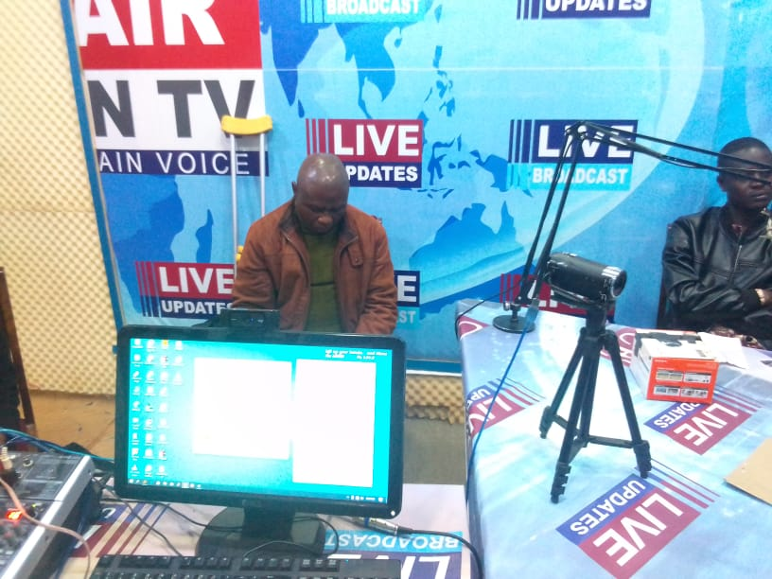 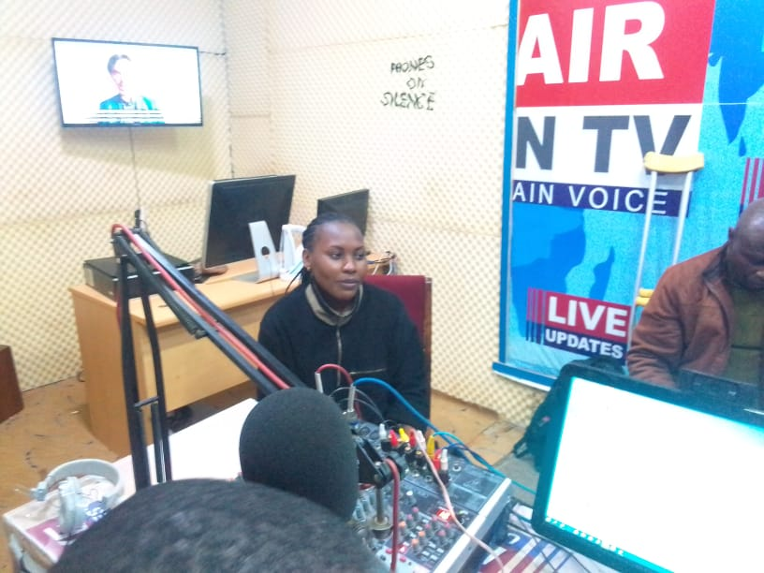 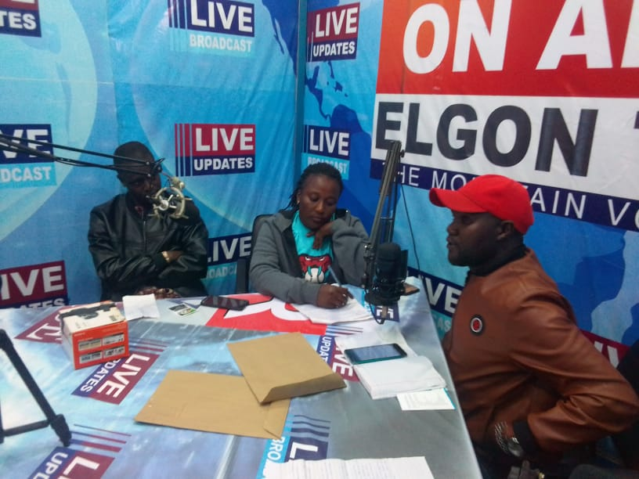  
***Picture Gallery***

***Figure 1.0*** *above shows the seating arrangement of the Panelists (at the fore front is Vanessa, Sharon MWOK Staffs, and Kosgei Chemutai, Victor, Twalla) during the Radio Talk Show in ELGON FM 95.34.*